Department of Microbiology

484 West 12th Avenue
Columbus, OH 43210-1292

Phone (614) 292-2301
Fax (614) 292-8120

November 30, 2010

Professor Larry Krissek
Chair, Arts and Sciences CCI
Re: Political Science BA

Dear Professor Krissek:

At the November 24, 2010 meeting of the Mathematics and Social, Behavioral, and Natural Sciences CCI Subcommittee the semester conversion plan for the Political Science BA program, submitted by the Department of Political Science, was reviewed. In his letter of support, Dr. Weisberg indicated that the major’s program has recently been revised, effective in 2008-09, and their semester conversion proposal for the BA program is a conversion with no significant changes in the structure. The committee felt the proposal was clear and comprehensive; we did however request that a few minor changes be made. These included:

- We noted a text omission the PACER Program Request page. The Program Learning Goals presented are incomplete. The description ends with an abbreviated statement for goal 2 and learning goals 3 and 4 are not presented. We did note that the goals are presented in their complete form later in the document.
- We asked that the curriculum map document indicate the levels (e.g. introductory or advanced, or other indicator) for the learning goals met by the individual courses.

Since these revisions were viewed as minor, the subcommittee unanimously approved the proposal and we have submitted it for the next step in the approval process.

Sincerely,
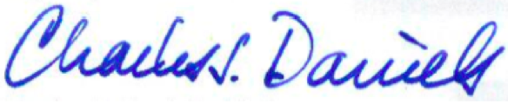

Charles J. Daniels, Ph.D.
Professor
Acting Subcommittee Chair for Nov. 24

